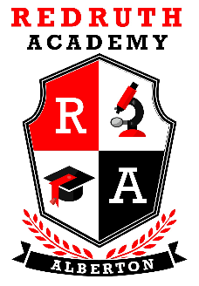
REDRUTH ACADEMY

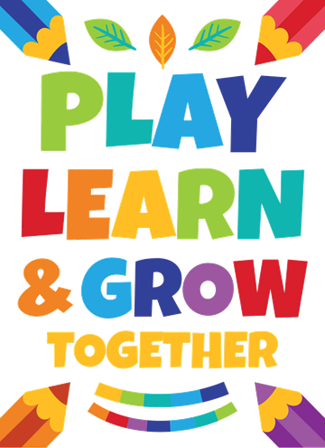



GENERAL INFORMATION: GRADE 1 - 9

19 CLINTON ROAD,
NEW REDRUTH, ALBERTON
TEL: 010 335 0334
EMAIL: info@redruthacademy.co.za

At Redruth Academy we offer a dynamic, multi-cultural environment.
APPLY TO BE PART OF OUR DYNAMIC SCHOOL
Small class numbers allow for
individual attention as well as effective group work. Working within a
technology enhanced environment, we focus on understanding the
learner’s potential and encouraging both logical and
creative thought processes depending on the learners
potential.

Communication with parents is done using a communi- cation book for foundation phase and newsletters used for news, calendar events, homework, fees, marks and links to useful resources, e-mail and termly newsletters.
COMMUNICATION

Educators select the best available workbooks and
textbooks available for learners in all subjects. All
CURRICULUM MATERIALS
academic materials are CAPS compliant and are updated based on the latest curriculum requirements and
educational developments. Assessment and monitoring include school-based assessment tasks, control tests and examinations. Report cards that comply with the
Schools Act are handed out termly.

The Foundation Phase includes four compulsory subjects for Grade 1 to 3 according to the CAPS curriculum:
SUBJECTS OFFERED
- English Home Language
- Afrikaans First Additional Language
- Mathematics
- Life Skills (includes Art and Physical Education).
For grade 4 to 6 the following subjects are added:
- Social Sciences
- Natural Sciences
For grades 7 to 9 the following subjects are added:
- Technology
- Creative Arts
- Economic and Management Sciences

EXTRA – CURRICULAR ACTIVITIES
These extra-curricular activities will be provided free to all learners:

- Physical Education – sports and fitness.
- Art—promoting creativity.
These extra-curricular activities will be provided at an additional
cost:
- Excursions – we take learners on outings which may include theme parks, movies, sports days, etc (cost applicable)

Events to look forward to during the year include the Reading
Awareness week as well as a market day run by our learners. We have various days promoting social responsibility, Mandela Day, where learners, educators and parents are very involved.
AWARENESS, COMPETITIONS & SPORTS

Civvies day is a term is used to bring awareness to various
courses as well as bring in an element of fun to keep our l earners minds focused and generally happens on a Friday.

We participate in competitions such as the book quiz, newspaper quiz, speech contest, spelling bees and the mathematics, science and EMS Olympiads.

We host a sports day annually and promote training / coaching in various sporting codes. Participation in tournaments is also
encouraged.

WHAT MAKES REDRUTH ACADEMY DIFFERENT?
At Redruth Academy, we foster a love for learning, where respect, tolerance, leadership and comradery are
cultivated within a warm and nurturing environment.

Our learners are confident yet respectful individuals and apply the skills and principles learnt at school in their everyday lives. Welcome to the growing community of families that believe in the value of a Redruth education.

We offer small classes and individualized learning through qualified and experienced educators. Our mathematics, science, language and other departments offer the best available educators and a reputation for excellence.

Our Code of Conduct, together with a demerit system, ensures that our students are disciplined and responsible and understand that there are consequences for their actions.

DOCUMENTATION NEEDED TO REGISTER
- Completed Redruth Academy enrolment form.
- The latest learner report (June or November report preferable).
- Parents ID Documents and Birth certificate / ID Document of learner.
- 1 x Passport size recent photo.
- Immunisation records.
- Transfer document from last school attended (not required for Grade 1).
- Latest report at the time of registration (if different from report given when applying).
- Other useful documents such as educational psychologist or medical reports.

